PLUMA ALIAJULUI cu memoria formei CuZnAl14

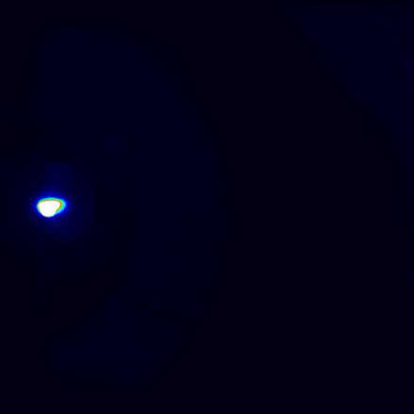 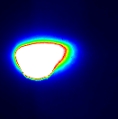

25 ns

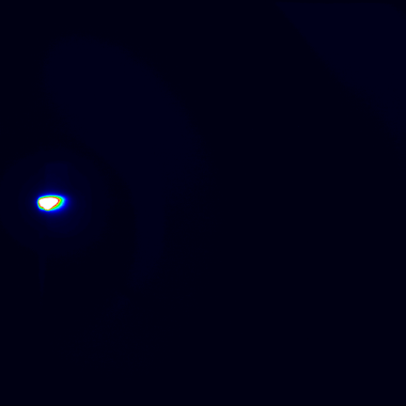 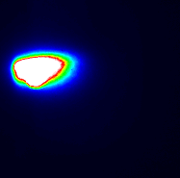

50 ns

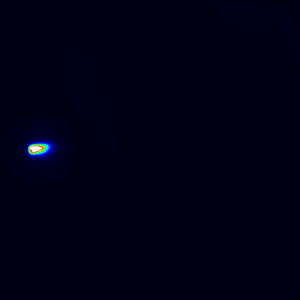 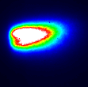

75 ns

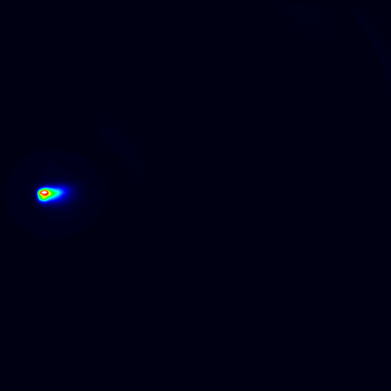 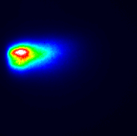

100 ns

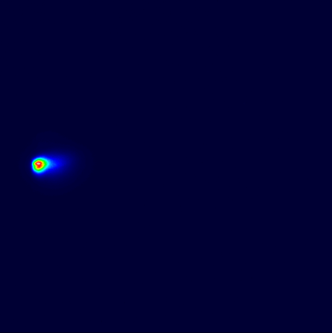 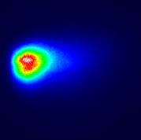

150 ns

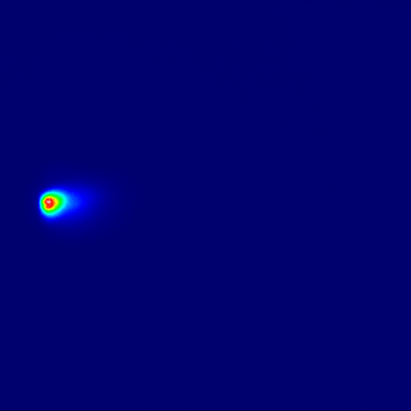 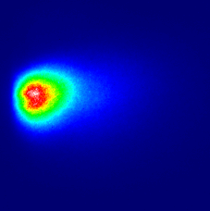

200 ns

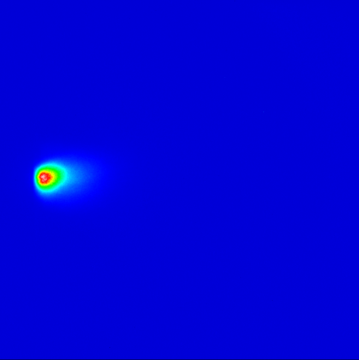 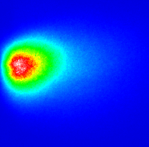

250 ns

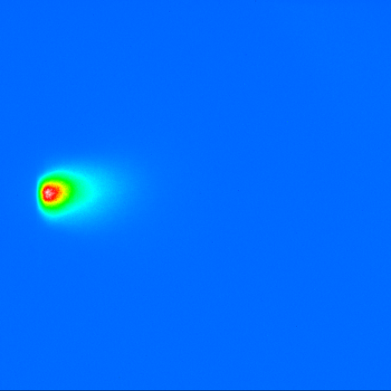 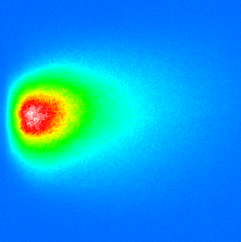

300 ns

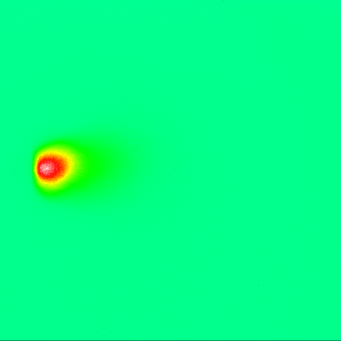 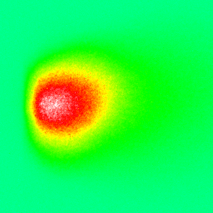

400 ns

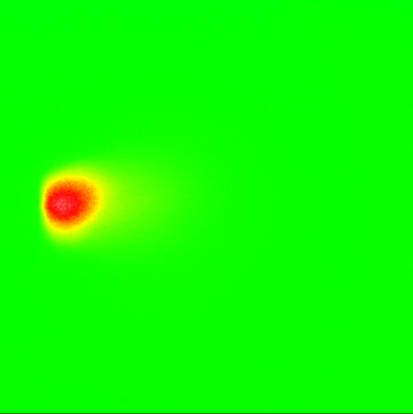 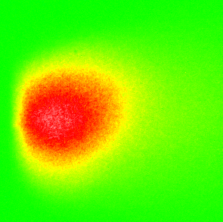

500 ns

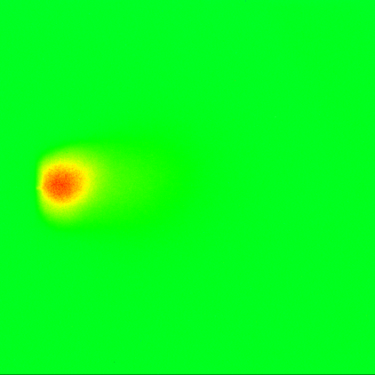 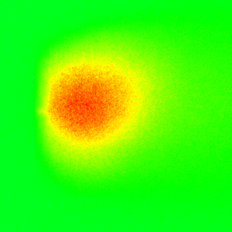

550 ns

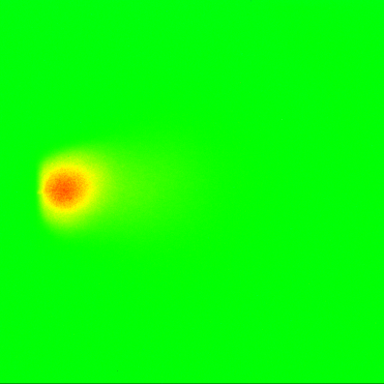 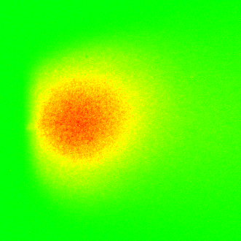

600 ns

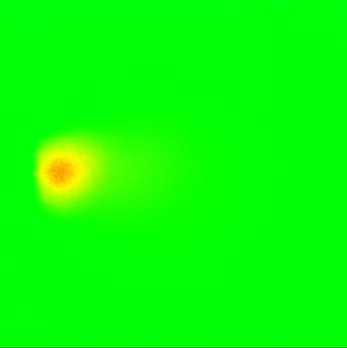 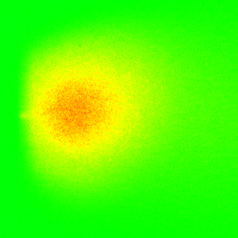

650 ns

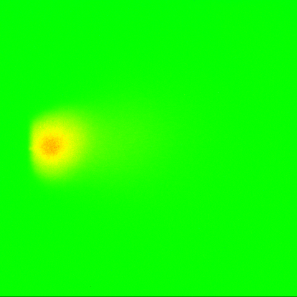 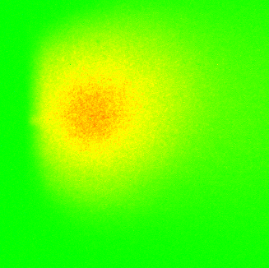

700 ns

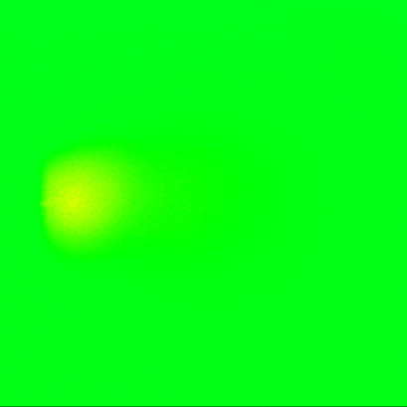 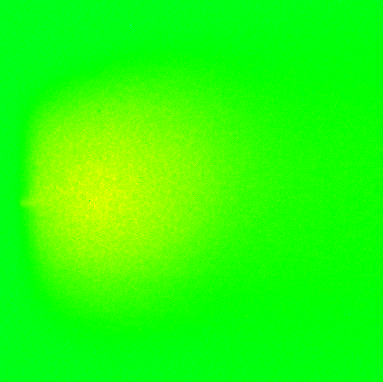

800ns

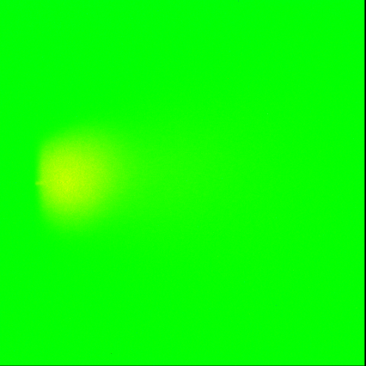

900 ns

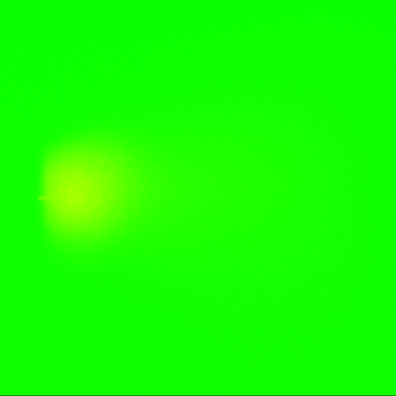 

1000 ns

 

1100 ns

|  |  |  |  |  |  |  |  |  |  |  |  |  |  |  |
| --- | --- | --- | --- | --- | --- | --- | --- | --- | --- | --- | --- | --- | --- | --- |
| Time [ns] | 25 | 50 | 75 | 100 | 150 | 200 | 300 | 400 | 500 | 600 | 700 | 800 | 900 | 1000 |
| Distance [mm] | 1.76 | 2.068 | 2.156 | 2.2 | 2.28 | 3.08 | 3.652 | 4.01 | 4.4 | 4.532 | 4.6 | 4.67 | 4.75 | 4.95 |

Analiza Spectrului plumei aliajului cu memoria formei CuZnAl 14



Spectrometrie optică indusă cu laser (LIBS)a plumei aliajului cu memoria formei CuZnAl 14

|  |  |  |  |  |  |
| --- | --- | --- | --- | --- | --- |
| Nr. Crt. | Observed wavelength air (nm) | Ion (element) | Aki  (s-1) | Ei  (cm-1) | Ek  (cm-1) |
| 1 | 308.08 | **(NiI)** | 8.7+06 | 1713.087 | 34163.264 |
| 2 | 308.98 | **(AlI)** | 2.4+06 | 44166.398 | 76521.7 |
| 3 | 324.75 | **(CuI)** | 1.39+08 | - | - |
| 4 | 327.39 | **(CuI)** | 1.37+08 | - | - |
| 5 | 328.03 | **(FeI)** | 5.4+07 | 26627.604 | 57104.22 |
| 6 | 330.12 | **(CuII)** | 5.3-02 | - | - |
| 7 | 334.44 | **(AlIV)** | 2.0-04 | 82408 | 853971 |
| 8 | 358.57 | **(FeI)** | 3.75+06 | 7376.76 | 35257.31 |
| 9 | 359.77 | **(NiI)** | 1.4+07 | 1713.087 | 29500.674 |
| 10 | 360.094 | **(FeIII)** | 3.8 | - | - |
| 11 | 365.39 | **(CrI)** | 4.5+05 | - | - |
| 12 | 368.65 | **(CuII)** | 1.2+07 | - | - |
| 13 | 394.4 | **(AlI)** | 4.93+07 | 0 | 25347.756 |
| 14 | 396.11 | **(FeI)** | 2.3+06 | 23051.742 | 48289.865 |
| 15 | 402.18 | **(FeI)** | 1+07 | 22249.428 | 47106.477 |
| 16 | 406.21 | **(PbI)** | 9.2+07 | - | - |
| 17 | 424.9 | **(CuI)** | 1.97+07 | - | - |
| 18 | 427.48 | **(CrI)** | 3.07+07 | 0 | 23386.35 |
| 19 | 437.76 | **(SiIII)** | 4.14+06 | 204828.06 | 227665.09 |
| 20 | 441.39 | **(CoII)** | 2.7+07 | - | - |
| 21 | 447.98 | **(AlIII)** | 2.4-01 | 167612.75 | 189928.49 |
| 22 | 450.94 | **(CuI)** | 2.75+07 | - | - |
| 23 | 452.99 | **(CrI)** | 1.1+06 | 20519.6 | 42589.25 |
| 24 | 453.97 | **(CuI)** |  |  |  |
| 25 | 458.61 | **(CrI)** |  |  |  |
| 26 | 464.95 | **(CrI)** |  |  |  |
| 27 | 466.19 | **(FeI)** |  |  |  |
| 28 | 467.36 | **(CuII)** |  |  |  |
| 29 | 467.92 | **(FeI)** |  |  |  |
| 30 | 472.15 | **(SiI)** |  |  |  |
| 31 | 480.99 | **(FeI)** |  |  |  |
| 32 | 490.9 | **(CuII)** |  |  |  |
| 33 | 491.1 | **(ZnII)** |  |  |  |
| 34 | 491.77 | **(FeIV)** |  |  |  |